**PRACTICAL-5**

1. **Start the MongoDB server by specifying -- replSet option. Following is the basic syntax**



1. **Now Open another command prompt for client. We will use this window to query our first server instance C:\>mongo --port 27018**

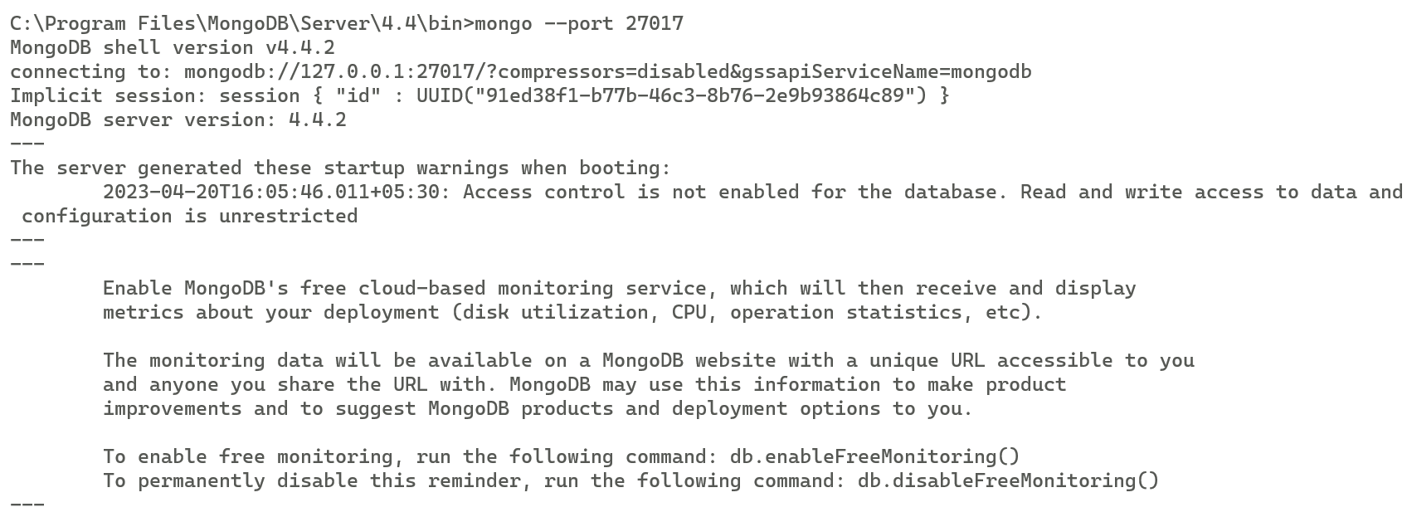

1. **Now Primary server is working. (Creating 1(first) Replicas of Primary instance) Syntax C:\Program Files\MongoDB\Server\4.2\bin>mongod --port 27019 --dbpath "C:\data2" --replSet testrep**

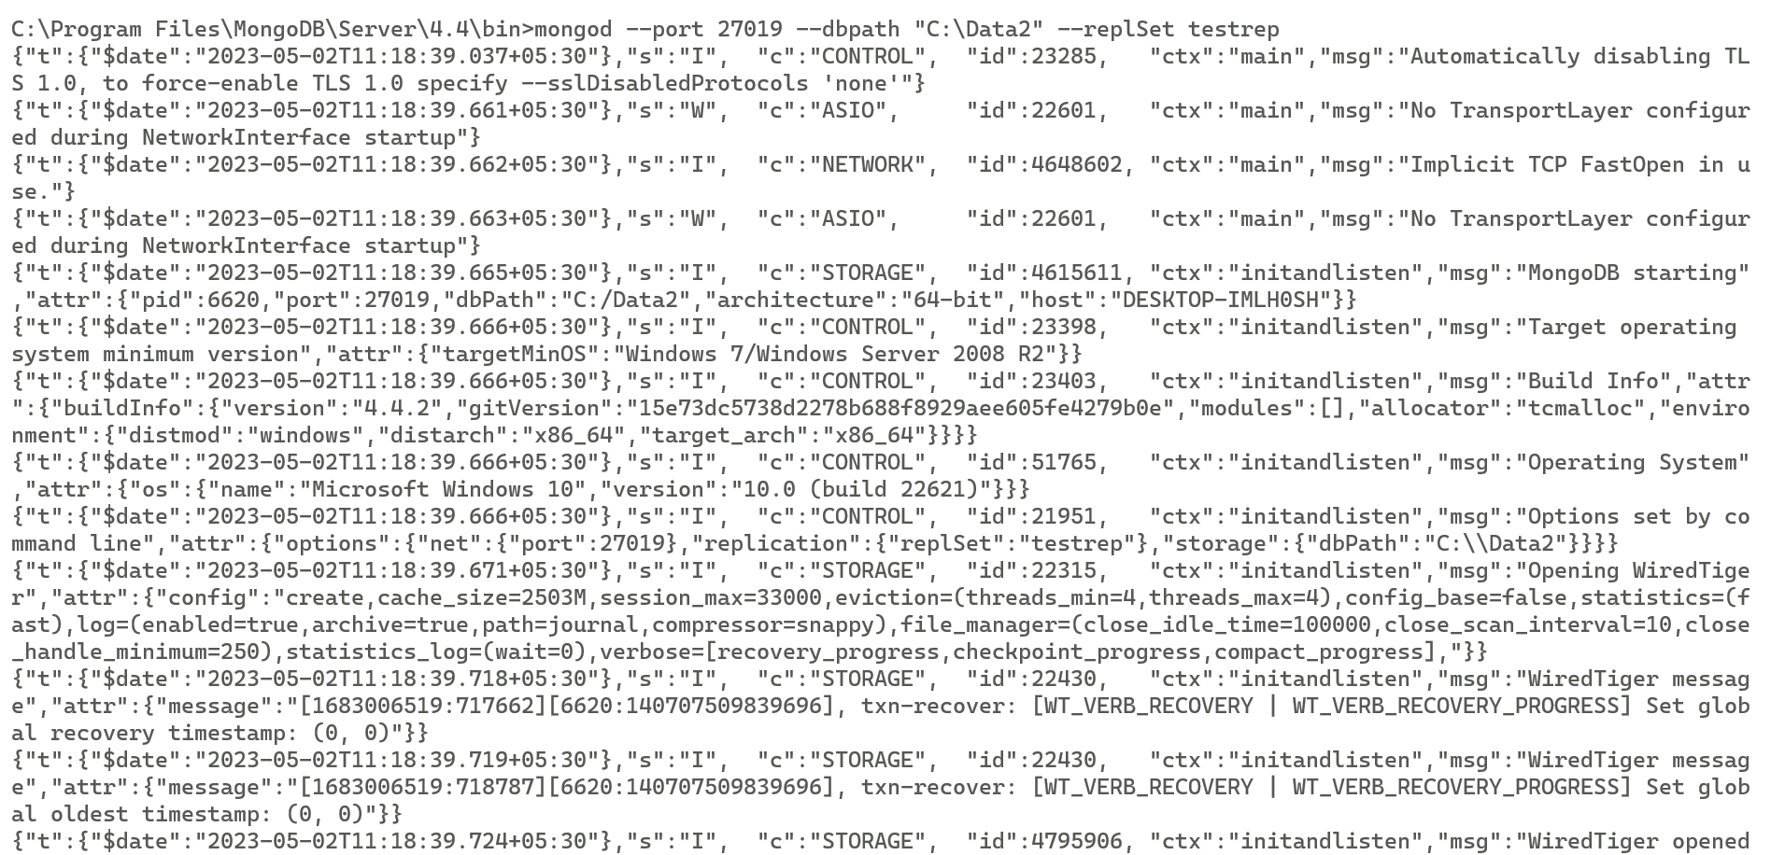

1. **Now Open another command prompt for client. We will use this window to query our second server instance C:\>mongo --port 27019**

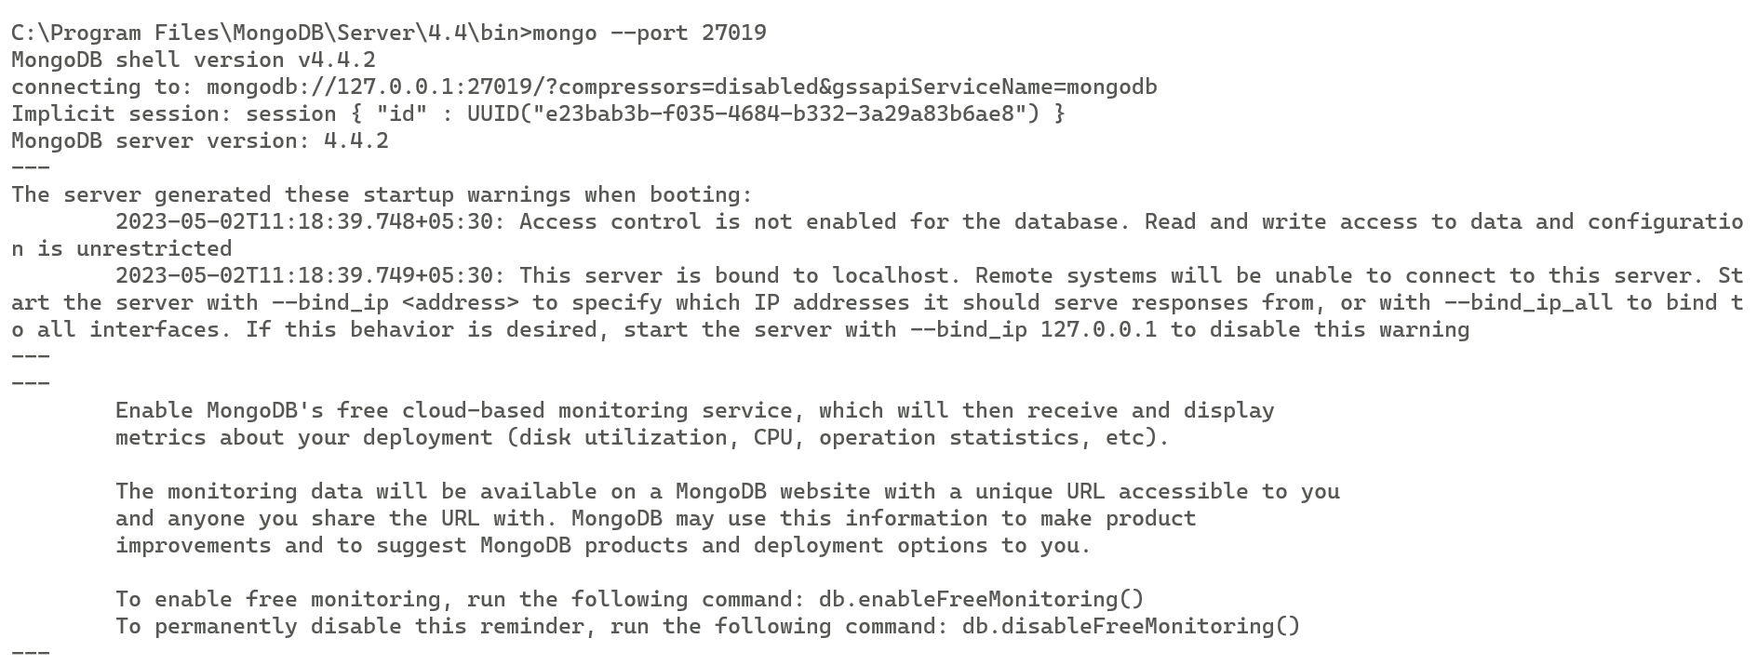

1. **Now go to the command prompt of Primary server’s Client instance. C:\>mongo --port 27018**

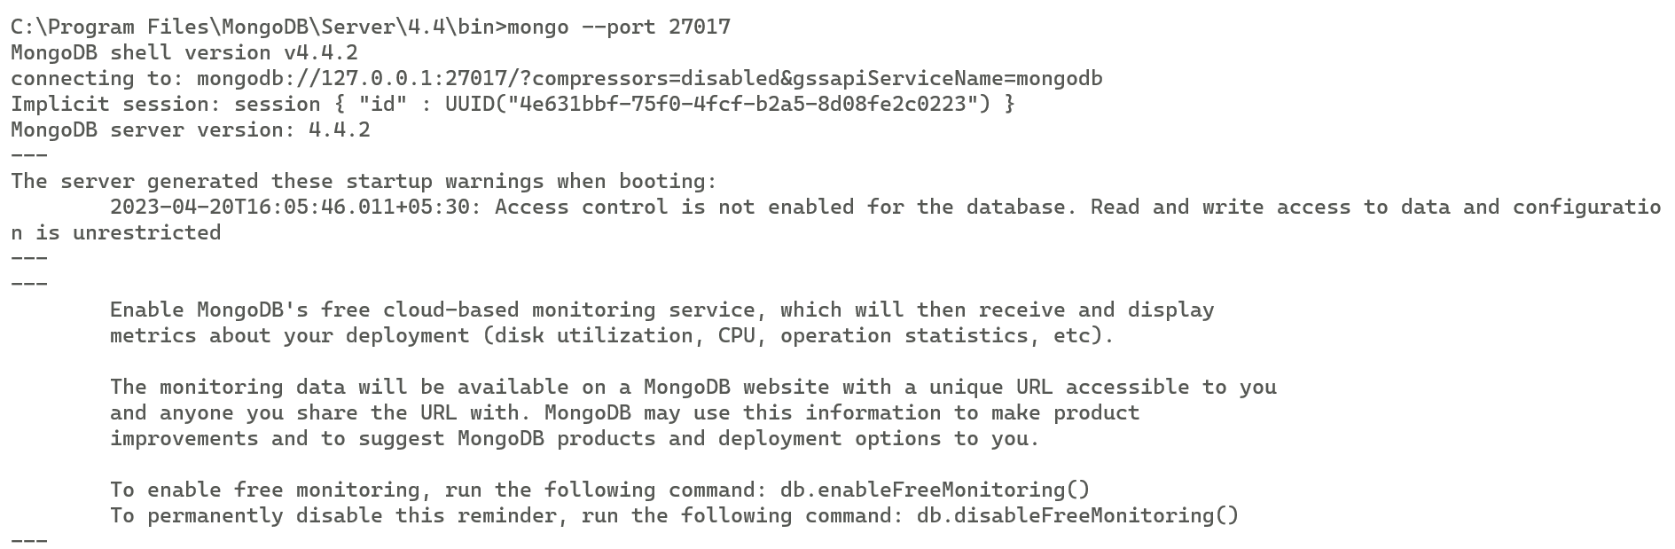

1. **Now type the following code config ={ _id : "testrep" , members :[ { _id : 0, host : "localhost:27018" } ] } Above code set id=0 to the first replica instance which is on port 27018.(PRIMARY INSTANCE)**

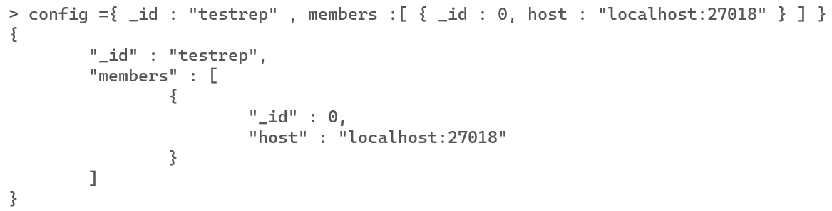

1. **After this write command rs.initiate(config) This command initiates a replica set with the current host as its only member. This is confirmed by the output, which should resemble the following:**

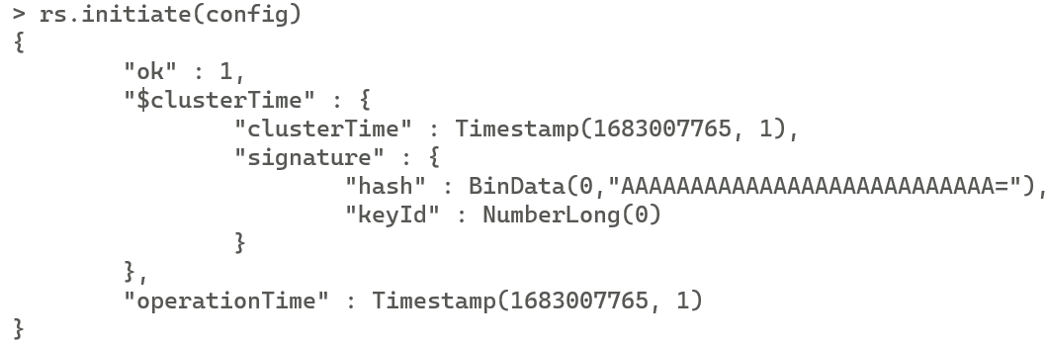

1. **After this writte write command rs.status()**

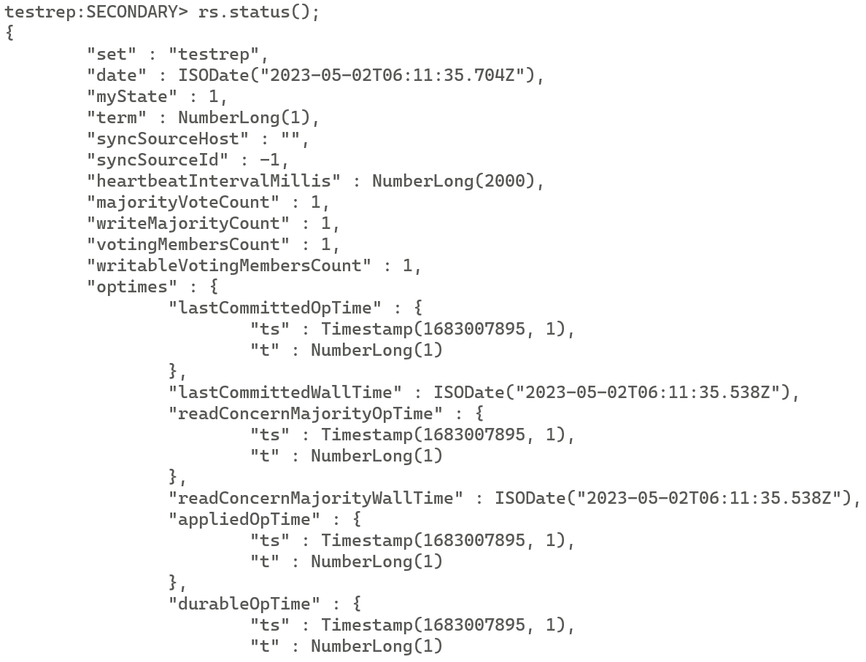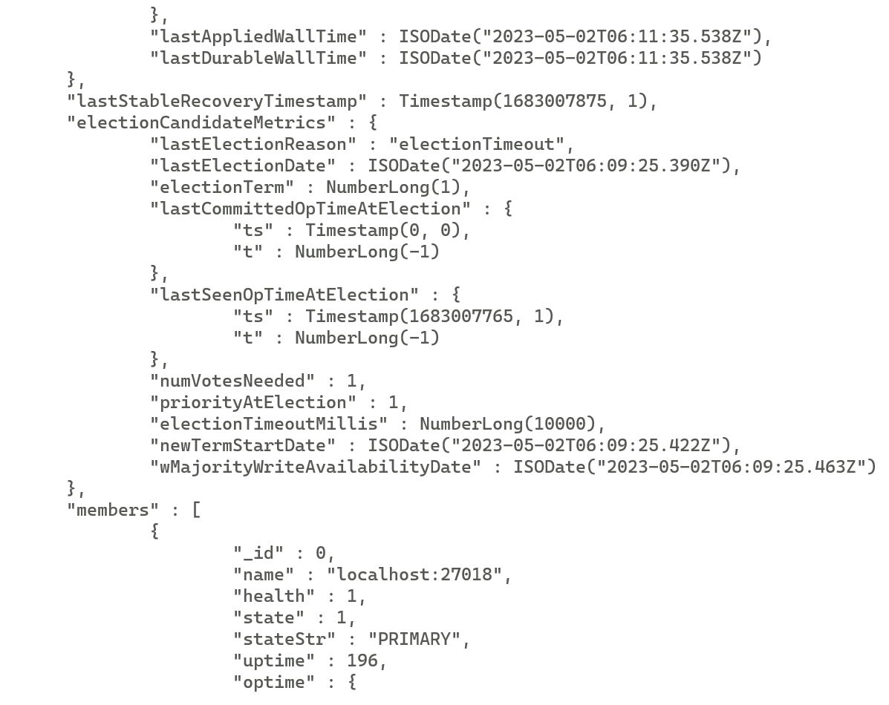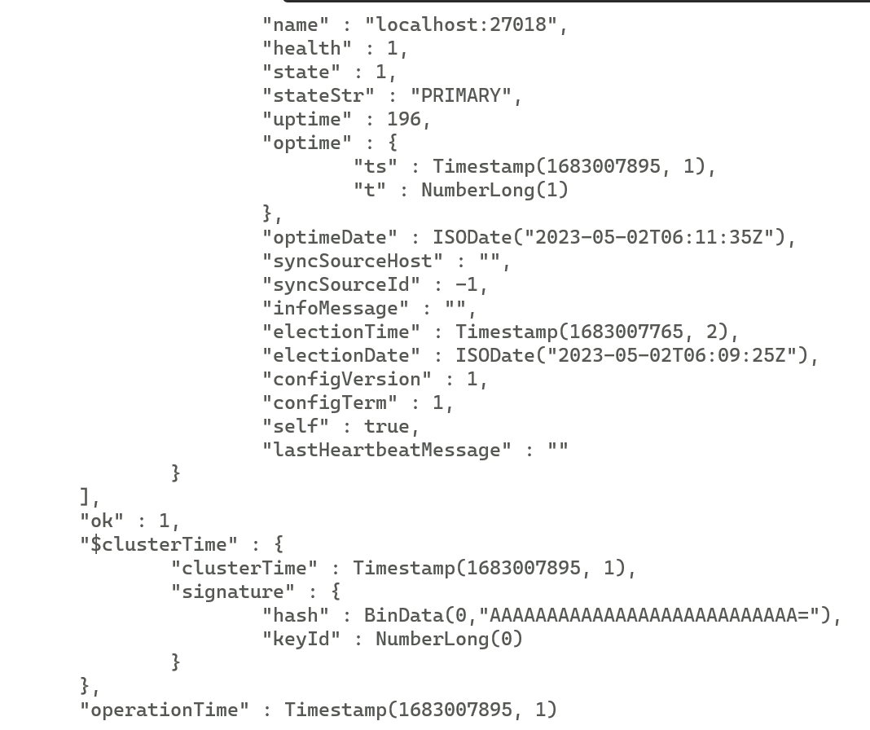

1. **Step 6(Creating 2(Second—port 27021) Replicas of Primary instance) Syntax C:\Program Files\MongoDB\Server\4.2\bin>mongod --port 27021 --dbpath "C:\data3" --replSet testrep**

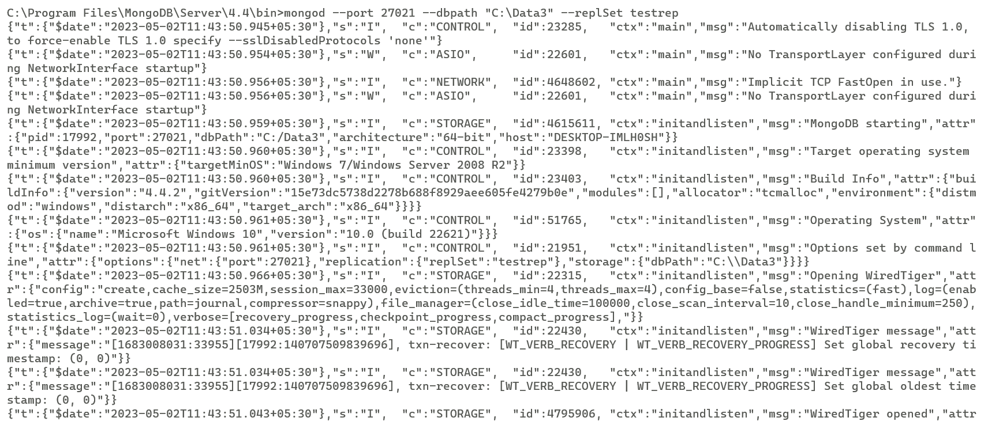

1. **After this start mongo client of 2 seconday instance.**

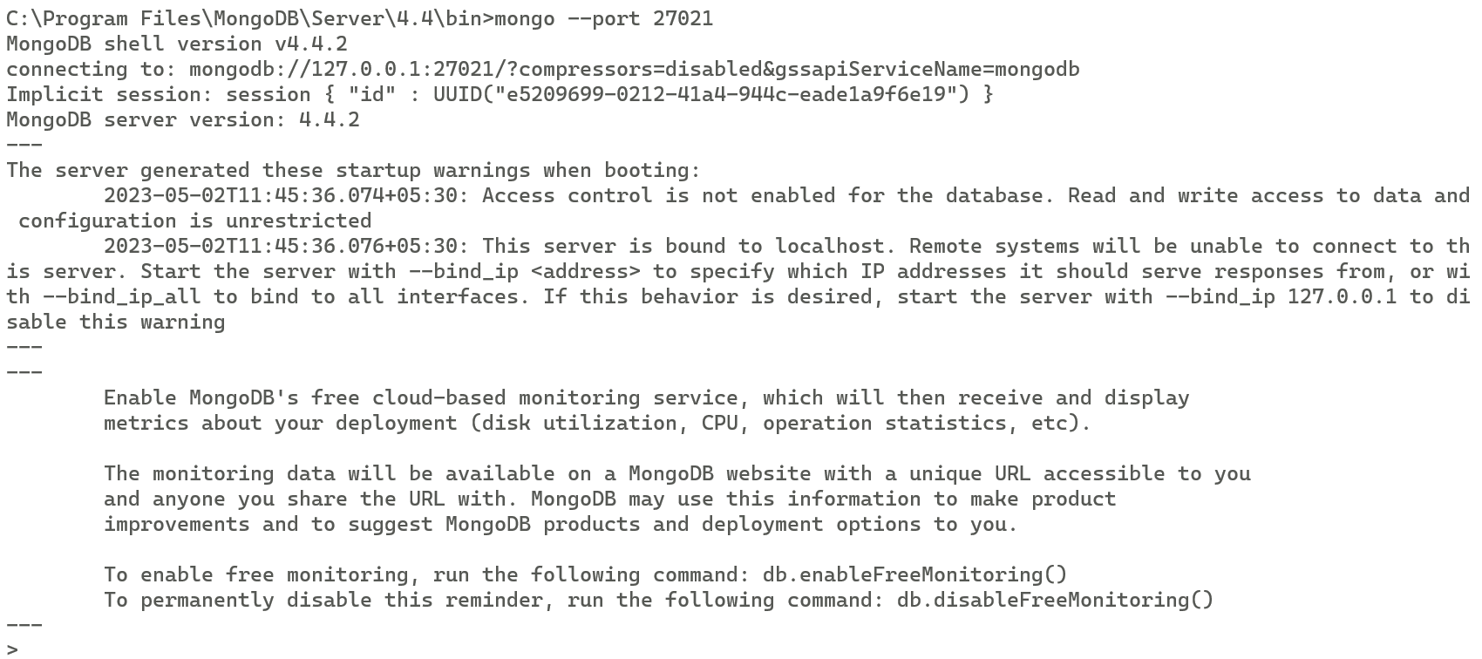

1. **Step 7 Now goto the CMD Client window of Primary Client(port 27018) Execute rs.add() method. Syntax rs.add(“localhost:27021”)**

rs.add(“localhost:27021”);

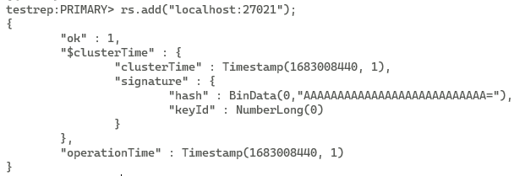

1. **After this execute rs.status(); command.**

**This will show status of our Cluster. In our cluster three instance first Primary and remaining two are replicas of primary instance.**



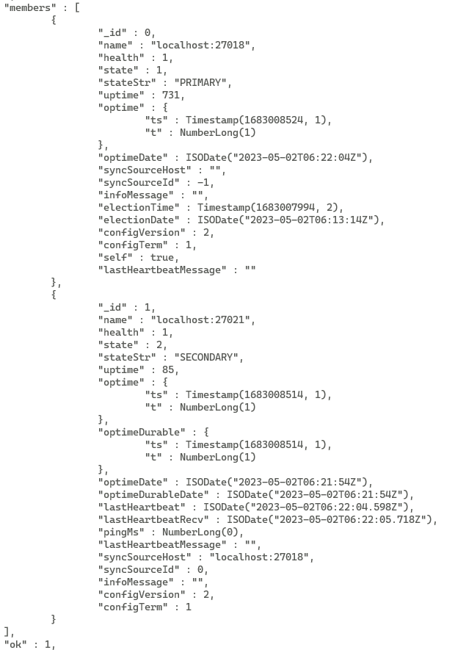



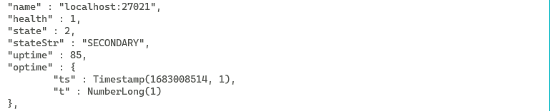

1. **On cmd window of(client of 27018 main) Add the replica of main instance which is created on local host port 27019 in Cluster using rs.add() method.**

rs.add(“localhost:27019”);

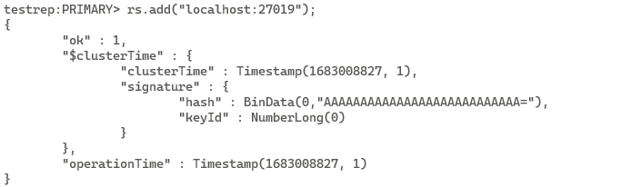

1. **Now execute rs.status() command so we can see now in our cluster there are two instance one is primary and other is secondary.**

